UNIT 3
Q1) Compare univariate and multivariate linear regression.
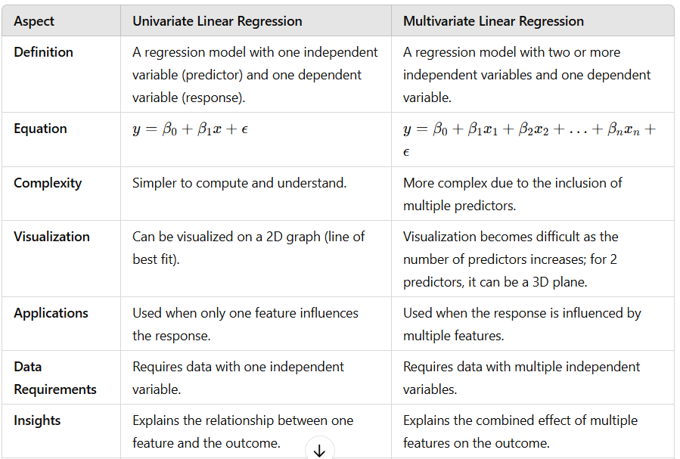
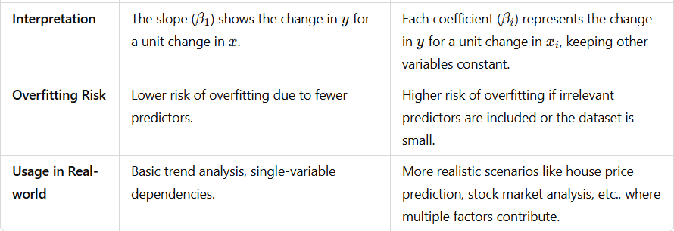
--------------------------------------------------------------------------------------------------------------------------------------------------
Q2) Describe the tradeoff between bias and variance using dart example.
There is a trade-off (need to balance bias and variance) to get the models just right for the job. If you denote the variable you are trying to predict as Y and the dependent variables as X, then you may assume that there is a relationship such that Y = f(X) + e where the error term e is normally distributed.
The error term is an aggregation of reducible error and irreducible error.
Total Error = Reducible Error + Irreducible Error
The Below Figure illustrates what it looks like to balance bias and variance.
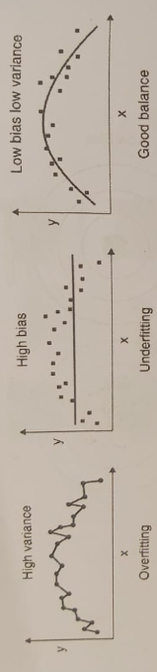
Bias and variance errors can, however, be minimized. Mathematically, the error function could be described as following.
Err(x) = Total Error = Bias² + variance + Irreducible Error
That third term, irreducible error, is the noise term in the true relationship that cannot fundamentally be reduced
by any model. Given the true model and infinite data to calibrate it, you should be able to reduce the bias and variance terms to 0. However, in a world with imperfect models and finite data, there is a trade-off between minimising the bias and minimising the variance. You cannot really minimise both perfectly at the same time.
To build a good model, you need to find a good balance between bias and variance such that it minimises the total error.
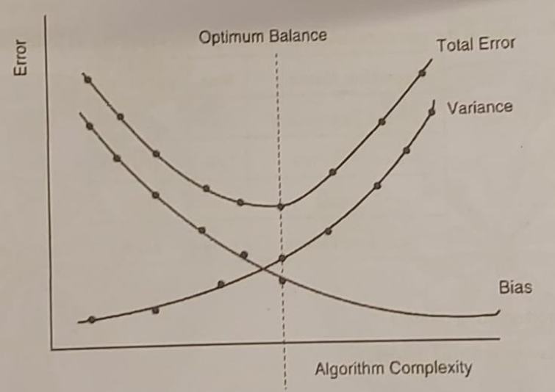
- Since bias is high for a simpler model and decreases with an increase in model complexity, the line representing bias exponentially decreases as the model complexity increases.
- Similarly, Variance is high for a more complex model and is low for simpler models. Hence, the line representing variance increases exponentially as the model complexity increases.
The most optimal complexity of the model is right in the middle, where the bias and variance intersect. These values of bias and variance would produce the least error and are preferred. An optimal balance of bias and variance would not overfit or underfit the model.
Bias
Dart Example: Darts are consistently off the target but clustered in one location. The throws are inaccurate but consistent.
High Bias: The darts miss the bullseye consistently because the thrower assumes an incorrect aim.
Low Bias: The darts are close to the bullseye, indicating the aim is correct.
Variance
Dart Example: Darts are scattered all over the board, indicating inconsistency in the throws. The thrower reacts too much to small changes in the environment.
High Variance: Darts are spread widely, even if some hit the bullseye.
Low Variance: Darts are tightly clustered, showing consistent throws.
Bias-Variance Tradeoff: The goal is to balance bias and variance for optimal accuracy.
High Bias, Low Variance: The darts are clustered but far from the bullseye. The model is simple and consistent but inaccurate (underfitting).
Low Bias, High Variance: The darts are scattered around the board. The model is complex but inconsistent (overfitting).
Optimal Tradeoff: Darts are tightly clustered around the bullseye. The model captures the data complexity without overreacting to noise.
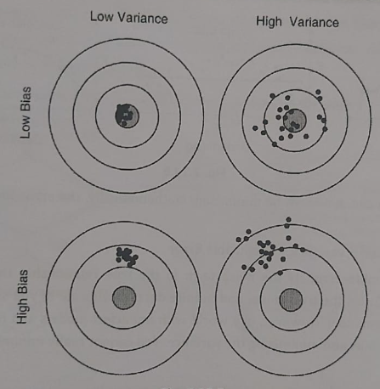
Q3) Explain the cost function used to evaluate the performance of regression.
A cost function establishes the relationship between events or a set of values to represent loss or penalty incurred in gaining something (say an event or value). It is also called as loss or error function. An optimisation problem seeks to minimise the cost function so that the maximum gains could be accomplished. For example, while training a machine learning model, you seek to minimise the error incurred in training. Typically, the error is represented (or named) as a cost function. The idea behind representing a cost function is that it can be minimised using mathematical operations.
1) Mean Error (ME)
Mean Error (ME) is the simplest of all cost functions. It is simply a mean (average) of the difference between the actual value and the predicted values. Let's take an example.
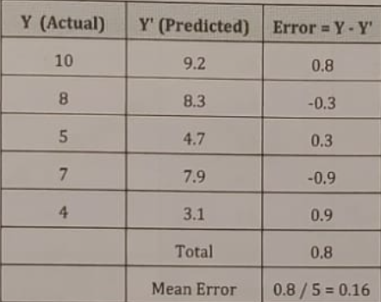
But there is a problem with this cost function. The errors can be both negative or positive and during summation, they tend to cancel each other out. In fact, it is theoretically possible that the errors are such that positive and negatives cancel each other to give zero error which could incorrectly mean a perfect model. So, Mean Error is not a recommended cost function.
2) Mean Squared Error (MSE)
Mean Squared Error (MSE), an improvement upon Mean Error (ME) cost function, squares the difference between the actual and predicted value to avoid negative values cancelling out positive values in error calculation. Let's take an example.
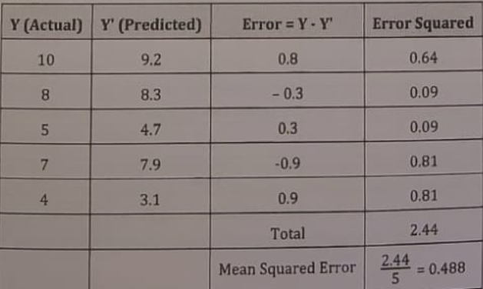
If you compare the MSE value (0.488) with the ME value (0.16) that you found for the same data, you find that MSE is a better way to calculate error when compared with ME. MSE is generally higher than ME for the same data indicating the error in the function.
3) Mean Absolute Error (MAE)
Mean Absolute Error (MAE) also attempts to solve the cancelling out problem with Mean Error (ME). MAE calculates the mean of the absolute value (without sign) of the difference between the actual value and the predicted value and that calculates the mean of the sum. Let's take an example.
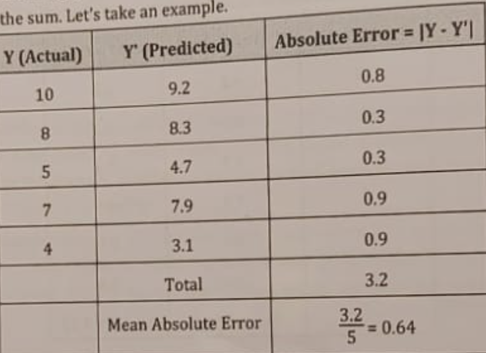
If you compare the MAE value (0.64) with the ME value (0.16) that you found for the same data, you find the MAE is a better way to calculate error when compared with ME. MAE is generally higher than ME for the same data indicating the error in the function.
4) Root Mean Squared Error (RMSE)
Root Mean Squared Error (RMSE) also attempts to solve the cancelling out problem with Mean Error (ME). RMSE takes the root of Mean Squared Error (MSE). Let's take an example.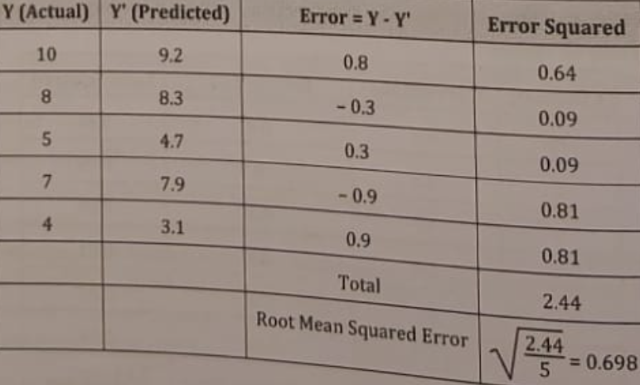
If you compare the RMSE value (0.698) with the ME value (0.16) that you found for the same data, you find that RMSE is a better way to calculate error when compared with ME. RMSE is generally higher than ME for the same data indicating the error in the function.
5) R-Squared
R-Squared (R² or the coefficient of determination) is a statistical measure in a regression model that determines the proportion of variance in the dependent variable that can be explained by the independent variable. In other words, R² shows how well the data fit the regression model (the goodness of fit). For example, R² of 60% reveals that 60% of the data fit the regression model. Generally, a higher R² indicates a better fit for the model.
Measures on how well the model explains the variance in the data.
Values range from 0 to 1:
R² = 1 : Perfect fit.
R² = 0 : Model does not explain any variability in the data.
Can be negative for very poor models.
Use Case:
Commonly used to evaluate model performance.
Indicates the proportion of variance in the target variable explained by the predictors.
-----------------------------------------------------------------------------------------------------------------------------------------------------
Q4) Explain gradient descent technique for optimization in linear regression
Derivative-based optimization is a technique that uses the derivatives (slopes) of a function to find its minimum or maximum. It relies on the mathematical properties of a function being differentiable. In simpler terms, it uses how steep the function is at a certain point to decide which direction to move to improve the outcome.
Key Characteristics of Derivative-Based Optimization:
Relies on Differentiability: The function being optimized must have a clear slope (i.e., differentiable).
Faster Convergence: It typically converges quickly for smooth, convex problems.
Gradient Information: Uses the gradient (first derivative) or higher-order derivatives like the Hessian (second derivative) to guide optimization.
Examples: Gradient descent, Newton's method, and quasi-Newton methods.
Gradient Descent for Optimization
Gradient descent is a derivative-based optimization algorithm primarily used to minimize a cost function, often in machine learning or statistical models. It adjusts parameters iteratively to reduce error and improve the model’s predictions.
Gradient descent is a mathematical technique used to find the minimum of a function by taking iterative steps in the direction of the steepest descent (negative gradient).
Characteristics of Gradient Descent:
Iterative: Works step by step until convergence.
Requires Learning Rate (α): Determines the size of steps taken. A small α\alphaα leads to slow learning; a large α can overshoot the minimum.
Scales Well: Works well for high-dimensional data.
Different Variants: Includes Batch, Stochastic, and Mini-batch gradient descent.
Steps of Gradient Descent:
Initialize Parameters: Start with random or zero values for the parameters.
Compute Predictions: Use the model to predict the target values.
Calculate Error: Compare predictions to actual values using a cost function (e.g., Mean Squared Error).
Update Parameters: Use the gradient of the cost function to adjust the parameters:
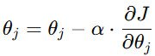 α: Learning rate; 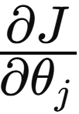 = Gradient of the cost function.
Repeat: Iterate until the cost function converges (i.e., stops decreasing significantly).
Simple Example of Gradient Descent:
Imagine you're at the top of a hill, blindfolded, and your goal is to reach the lowest point (the valley).
At each step, you feel the slope of the ground around you.
You take small steps downhill in the direction where the slope decreases the most.
Eventually, you'll reach the bottom of the hill.
-----------------------------------------------------------------------------------------------------------------------------------------------------
Q5) What is least square method? Explain least square method in the context OF REGRESSION
Least Square Method is used to derive a generalized linear equation between two variables. when the value of the dependent and independent variable is represented as the x and y coordinates in a 2D cartesian coordinate system. Initially, known values are marked on a plot. The plot obtained at this point is called a scatter plot.
Then, we try to represent all the marked points as a straight line or a linear equation. The equation of such a line is obtained with the help of the Least Square method. This is done to get the value of the dependent variable for an independent variable for which the value was initially unknown. This helps us to make predictions for the value of dependent variable.
This method aims at minimizing the sum of squares of deviations as much as possible. The line obtained from such a method is called a regression line or line of best fit.
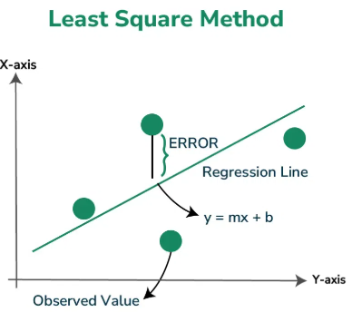
Formula for Least Square Method : Least Square Method formula is used to find the best-fitting line through a set of data points. For a simple linear regression, which is a line of the form y=mx+c, where y is the dependent variable, x is the independent variable, a is the slope of the line, and b is the y-intercept, the formulas to calculate the slope (m) and intercept (c) of the line are derived from the following equations:
Slope (m) Formula: m = (n * ∑xy - ∑x * ∑y) / (n * ∑x² - (∑x)²)​
Intercept (c) Formula: c = (∑y)−a(∑x) / n​
Where:
n is the number of data points,
∑xy is the sum of the product of each pair of x and y values,
∑x is the sum of all x values,
∑y is the sum of all y values,
∑x2 is the sum of the squares of x values.
The steps to find the line of best fit by using the least square method is discussed below:
Step 1: Denote the independent variable values as xi and the dependent ones as yi.
Step 2: Calculate the average values of xi and yi as X and Y.
Step 3: Presume the equation of the line of best fit as y = mx + c, where m is the slope of the line and
represents the intercept of the line on the Y-axis.
Step 4: The slope m can be calculated from the following formula:
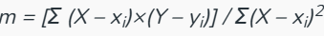
Step 5: The intercept c is calculated from the following formula: c = Y – mX
Thus, we obtain the line of best fit as y = mx + c, where values of m and c can be calculated from the formulae defined above.
-----------------------------------------------------------------------------------------------------------------------------------------------------
Q6) What is multiple regression? How it is different from simple linear regression
Multiple Regression is a statistical technique used to model the relationship between a dependent variable (target) and two or more independent variables (predictors). The goal is to predict the dependent variable based on the values of the independent variables by fitting a linear equation.
The general equation for multiple regression is:
Where: y: Dependent variable (target).
x1,x2,…,x_{n} ​: Independent variables (predictors).
β0​: Intercept.
β1,β2,…,βn ​: Coefficients (weights) for each predictor.
ϵ: Error term (difference between actual and predicted values).
Simple Linear Regression Example:
Predicting a student’s exam score (y) based on hours studied (x):
y=10+5xy = 10 + 5xy=10+5x
If x=3x = 3x=3 hours, y=10+5(3)=25y = 10 + 5(3) = 25y=10+5(3)=25 marks.
Multiple Regression Example:
Predicting a house price (y) based on size (x1​) and number of bedrooms (x2​):
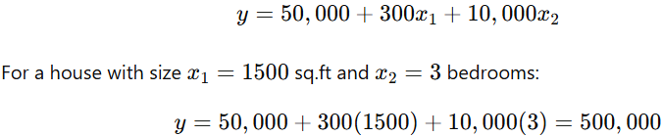
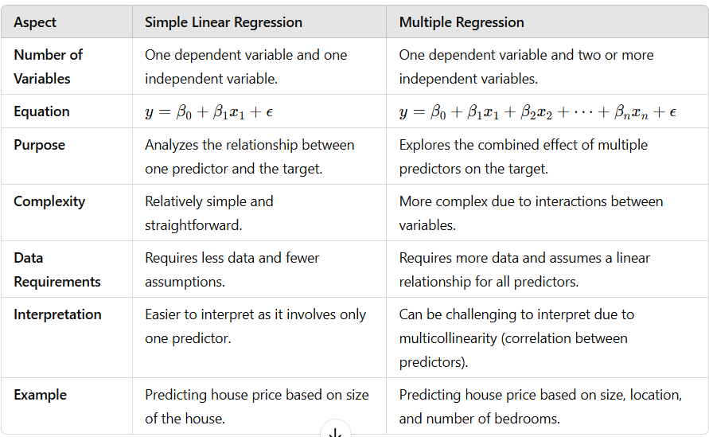
Q7) What do you mean by coefficient of regression? Explain SSE, MSE and MAE in context of regression.
The coefficient of regression represents the numerical value that quantifies the relationship between an independent variable (x) and the dependent variable (y) in a regression model. It indicates how much y is expected to change when x changes by one unit, assuming other variables are held constant.
In Simple Linear Regression, there is one coefficient (β1​) for the independent variable.
In Multiple Regression, there are multiple coefficients (β1, β2, …, βn ​) for the independent variables.
Context of Coefficient:
If the coefficient is positive, y increases as xxx increases.
If the coefficient is negative, y decreases as xxx increases.
The magnitude of the coefficient indicates the strength of the relationship.
For example, in the equation y=5+2xy = 5 + 2xy=5+2x:
2 is the coefficient, meaning y increases by 2 units for every 1 unit increase in x.
1. Sum of Squared Errors (SSE): SSE measures the total squared difference between the observed values (y_{i}) and the predicted values (y^_{i}) in a regression model.
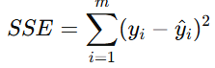
y^{i} : Actual value of the i^{th} observation.
y^_{i} ​: Predicted value from the regression model.
m: Total number of observations.
Significance:
SSE quantifies the model's error; smaller values indicate better fit. However, it does not account for the number of observations or scale, so other metrics are often used.
2. Mean Squared Error (MSE):
Significance:
MSE penalizes larger errors more heavily because it squares the errors.
Smaller MSE values indicate a better fit.
It is sensitive to outliers.
3. Mean Absolute Error (MAE):
Significance:
MAE provides a straightforward measure of error, expressed in the same units as the target variable.
Unlike MSE, MAE does not square the errors, so it is less sensitive to outliers.
A smaller MAE indicates better performance.
-----------------------------------------------------------------------------------------------------------------------------------------------------
Q8) Explain under fit, over fit and just fit models for Regression
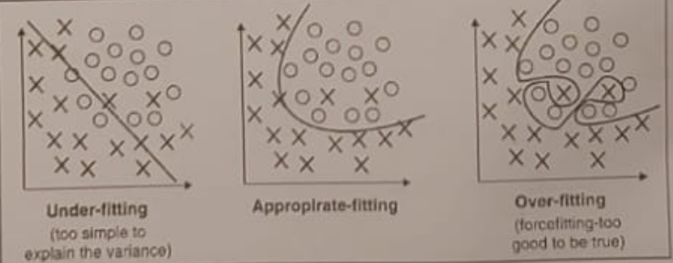
Overfitting:
- Overfitting occurs when the model matches the training data too closely, causing it to perform poorly on new data.
- Overfitting happens when a model learns the detail and noise in the training data to the extent that it negatively impacts the performance of the model on new data.
- This means that the noise or random fluctuations in the training data is picked up and learned as concepts by the model. The problem is that these concepts do not apply to new data and negatively impact the model's ability to generalize and carry out machine learning tasks.
- Overfitting is more likely with nonparametric and nonlinear models that have more flexibility when learning a target function. As such, many nonparametric machine learning algorithms also include parameters or techniques to limit and constrain how much detail the model learns.
Example: Using a high-degree polynomial regression that fits every training data point precisely but fails to generalize.
Underfitting
- Underfitting occurs when the model can neither model the training data nor work with the new data, causing it to perform poorly.
- If the target function is kept too simple, it may not be able to learn the essential features and characteristics of the training data. Underfitting could potentially happen due to unavailability of sufficient training data or incorrect selection of features.
- An underfit machine learning model is not a suitable model and it has a poor performance on the training data. Underfitting is often not discussed as it is easy to detect given a good performance metric.You continue to tune the parameters until you get a satisfactory model. Underfitting can also be avoided by using more training data and also by carefully selecting the features on which the model is trained.
Example: Trying to fit a linear regression line to a dataset with a non-linear relationship.
Just Fit Model:
Definition: A just fit model strikes the right balance between simplicity and complexity, capturing the essential patterns in the data without overfitting or underfitting.
Characteristics:
Good performance on both training and testing data.
Low bias and low variance.
Example:
Using a polynomial regression of appropriate degree that captures the underlying relationship without overfitting.
Graph: The regression line appropriately follows the data points, balancing fit and generalization.
-----------------------------------------------------------------------------------------------------------------------------------------------------
Q9) What is univariate and multivariate regression? Explain any three measures of Evaluation of performance of regression model
Univariate Regression:
Univariate regression refers to a type of regression analysis where there is only one independent variable (predictor) and one dependent variable (target). The goal is to understand the relationship between these two variables and to make predictions.
Equation: 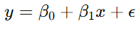
Where:
Y is the dependent variable (target).
X is the independent variable (predictor).
Β​₀ is the intercept (constant).
β₁​ is the coefficient (slope).
ϵ is the error term (residual).
Example: Predicting the price of a house (y) based on its size (x).
Characteristics:
Simple model, easy to implement and interpret.
Assumes a linear relationship between the independent and dependent variables.
Limited in capturing more complex relationships because it considers only one predictor.
Advantages:
Simple and easy to implement.
Fast computation.
Easy to interpret.
Disadvantages:
Limited predictive power.
May exclude important variables.
Poor performance on complex data.
Multivariate Regression:
Multivariate regression refers to a type of regression analysis where multiple independent variables (predictors) are used to predict a single dependent variable (target). This allows us to capture the combined effect of several factors on the outcome.
Equation:
Where:
Y is the dependent variable.
x1,x2,…,x_{n} are the independent variables (predictors).
β₀ is the intercept.
β1,β2,…,βn ​ are the coefficients.
ϵ is the error term.
Example: Predicting the price of a house based on size, location, and age of the house.
Characteristics:
Allows for more complex relationships by including multiple predictors.
Requires careful handling of multicollinearity (when predictors are highly correlated).
More flexible than univariate regression but can be more difficult to interpret due to the higher number of variables involved.
Advantages:
Better predictive accuracy.
Captures complex relationships.
Controls for confounding variables.
Disadvantages:
Increased complexity.
Risk of multicollinearity.
Higher risk of overfitting.
More computationally expensive.
When evaluating the performance of a regression model, we use various metrics to understand how well the model predicts the target variable and its accuracy. Here are three common measures:
1. Mean Squared Error (MSE)
2. Mean Absolute Error (MAE)
3. R-Squared
-----------------------------------------------------------------------------------------------------------------------------------------------------
Q10) Which Cost Function is More Suitable for Datasets with Outliers Representing Anomalies?
when dealing with outliers representing anomalies, the best cost function depends on how much you want to penalize these anomalies:
Most Suitable Cost Function:
Mean Absolute Error (MAE) is generally more suitable for datasets with outliers or anomalies because it is less sensitive to large errors compared to MSE or RMSE. This makes MAE more robust when you have extreme values that should not disproportionately influence the model’s evaluation.
Why MAE is Suitable:
Robustness to Outliers: Unlike MSE and RMSE, which square the errors and penalize larger errors more heavily, MAE treats all errors equally, making it more resilient when there are anomalies or outliers in the data.
Real-World Scenarios: In many real-world applications, outliers may represent rare but important occurrences (e.g., fraudulent transactions in financial data or rare events in a time series). These anomalies shouldn't overly distort the overall model performance, making MAE a better choice.
Limitations of MSE and RMSE:
Sensitivity to Outliers: Since both MSE and RMSE square the error terms, outliers can drastically increase the cost function, potentially leading the model to focus too much on minimizing these large errors, which may not be desired when dealing with anomalies.
Practical Example: Imagine a dataset of house prices, where most houses are in the $200k-$500k range, but a few rare properties are priced at $5M. Using MSE or RMSE would penalize these rare high-priced properties heavily, potentially distorting the model’s behavior for the typical house prices. On the other hand, MAE would not exaggerate the effect of these outliers, resulting in a model that performs better on the general dataset.
-----------------------------------------------------------------------------------------------------------------------------------------------------
Q11) What are the different ways to prevent overfitting
Overfitting occurs when a model learns not just the underlying pattern in the training data, but also the noise, leading to poor generalization on unseen data. There are several strategies to prevent overfitting, including cross-validation, regularization, and pruning. Let's explore these methods in detail:
1. Cross-Validation
Cross-validation is a technique used to evaluate the performance of a model by splitting the data into multiple subsets (folds). It helps ensure the model generalizes well by training and testing it on different portions of the data.
How it works:
- In k-fold cross-validation, the data is split into k subsets. The model is trained on k-1 subsets and tested on the remaining one. This process is repeated k times, each time using a different subset as the test set, and the performance is averaged across all iterations.
- Leave-One-Out Cross-Validation (LOOCV) is an extreme case of cross-validation where each data point is used as a test set exactly once, and the model is trained on the remaining data.
Benefits:
Provides a more reliable estimate of model performance by reducing the impact of random fluctuations in the dataset.
Helps detect overfitting by evaluating the model’s performance on different subsets, ensuring it doesn't just memorize the training data.
2. Regularization
Regularization helps to prevent linear models from overfitting training data examples (that is, memorising patterns instead of generalising them) by penalising extreme weight values. There are two popular techniques for regularisation:
a) L1 Regularization (Lasso Regression)
- L1 regularisation has the effect of reducing the number of features used in the model by pushing to zero the weights of features that would otherwise have small weights.
- As a result, L1 regularization results in sparse models and reduces the amount of noise in the model.
L1 regularisation tries to estimate the median of the data to avoid overfitting.
- It is also called as Lasso regression (regularisation) technique.
Cost function: 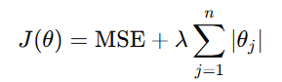
Where λ is the regularization parameter, and θ_{j} ​ represents the model's coefficients.
b) L2 Regularization (Ridge Regression)
- L2 regularisation results in smaller overall weight values and stabilises the weights when there is high correlation between the input features.
- L2 regularisation tries to estimate the mean of the data to avoid overfitting.
- L2 regularisation is more commonly used than L1 regularisation.
- It is also called as Ridge regression (regularisation) technique.
Cost function: 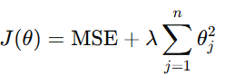 Where λ controls the strength of the penalty.
Benefits:
- Both methods help to control model complexity and improve generalization by adding a penalty for large weights, leading to a simpler, more interpretable model.
- Regularization is particularly useful when there are many features or when the dataset is prone to noise.
3. Pruning (In Decision Trees)
- Pruning is a technique used specifically for decision trees to prevent them from becoming overly complex. It involves removing branches of the tree that have little importance or are likely to lead to overfitting.
- Pruning reduces the tree’s complexity and helps ensure that the model does not fit noise in the training data.
- It reduces the risk of overfitting and improves the model's ability to generalize on unseen data.
- It leads to a more interpretable model, as the tree becomes smaller and simpler.
-----------------------------------------------------------------------------------------------------------------------------------------------------
Q12) State and explain need of Regression analysis.
Regression analysis is a statistical technique used to understand the relationship between one dependent variable (outcome) and one or more independent variables (predictors). It is widely applied across various fields to make predictions, assess impacts, and identify trends.
Why Regression Analysis is Needed?
1. Prediction:
Regression models help predict the value of a dependent variable based on the known values of one or more independent variables.
Example: Predicting house prices based on features like size, location, and number of bedrooms
2. Relationship Identification:
It helps identify the strength and direction of relationships between variables (positive, negative, or no relationship).
Example: Understanding how temperature affects ice cream sales.
3. Trend Analysis:
Regression aids in identifying trends or patterns in data over time.
Example: Analyzing sales growth over the past decade.
4. Decision Making:
Regression results can guide businesses or policymakers in making data-driven decisions.
Example: Determining which marketing strategy leads to higher customer retention.
5. Optimization:
It helps optimize systems or processes by determining the best combination of inputs.
Example: Optimizing advertising spend across channels to maximize revenue.
Applications of Regression Analysis
- Business and Economics: Forecasting sales, estimating demand, or analyzing pricing strategies.
- Healthcare: Predicting patient outcomes or identifying factors influencing disease progression.
- Engineering: Modeling system performance or failure rates.
- Social Sciences: Studying the impact of demographic factors on voting behavior.

